# Module 5 Lab 1

# Brandon Trinkle

# IFT 458: Middleware Prog & Database Sec

# Professor: Dinesh Sthapit

# Mar 15, 2025

# Module 5 Lab 1

1. *Screenshots of the installed Git and VSCode on your system.*

1. *Terminal showing the successful cloning of the repository and creation of a new branch.*

1. *Code snippets showing the middleware function and its integration into the server file.*

1. *Source control panel in VSCode showing staged changes and the commit message.*

1. *Terminal showing the successful git push command.*

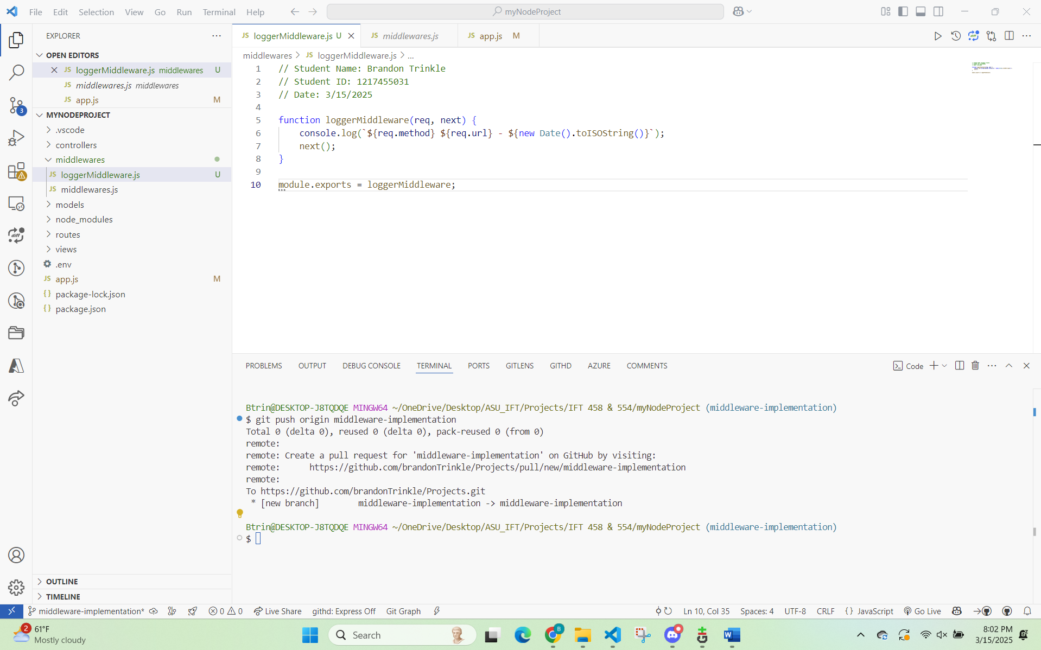

1. *GitHub webpage showing the opened pull request.*

